

**TECHNICAL PROPOSAL**

**RFP TITLE: Emirates News Agency System**

**RFQ No:** **671100**

**For: National Media Council**

**Submitted by:**

Verbat Technologies   
02.07.19

**DIRECTORY.**

1 KEY DETAILS. 3

2 EXECUTIVE SUMMARY 4

3 STATEMENT OF WORK 5

3.1 SCOPE 5

3.2 FUNCTIONAL REQUIREMENTS 5

3.3 NON-FUNCTIONAL REQUIREMENTS (OTHERS) 10

3.4 PROJECT ASSUMPTIONS 10

3.5 TECHNICAL CONFIGURATIONS 13

**3.5.1** **DEVELOPMENT TOOLS** 13

**3.5.2** **BROWSER** 13

**3.5.3** **HARDWARE** 13

**3.5.4** **Technical Standards** 13

**3.5.5** **Technical Guidelines** 14

4 OUT OF SCOPE 15

5 PROJECT DELIVERY 16

**5.1.1** **PROJECT MANAGEMENT** 16

**5.1.2** **ROLES & RESPONSIBILITIES** 16

**5.1.3** **SUPPORT AND SERVICES** 17

**5.1.4** **STANDARD DELIVERY ACTIVITY SUMMARY** 18

**5.1.5** **DELIVERABLES** 18

**5.1.6** **ESTIMATED DELIVERY TIME** 18

**5.1.7** **RISK CONTINGENCY PLANNING** 19

6 CHANGE MANAGEMENT 20

7 MAINTENANCE & SUPPORT 21

8 TERMS AND CONDITIONS 24

8.1 STANDARD ACCEPTANCE CRITERIA 24

8.2 WARRANTY 25

8.3 SOURCE CODE & INTELLECTUAL PROPERTY RIGHTS 25

8.4 GENERAL TERMS AND CONDITIONS 25

8.5 GENERAL ADMINISTRATIVE, TECHNICAL & FUNCTIONAL ASSUMPTIONS 26

9 COMPANY REFERENCES 28

10 ABOUT US 32

# KEY DETAILS.

**PROJECT NAME CLIENT**

Emirates News Agency System National Media Council

**CLIENT CONTACT PROPOSAL ID NO.**

Al-Sabki AD/TP/02072019/2816/1

024044282

**PROPOSAL SUBMISSION ANTICIPATED START DATE**

02.07.19TBA

**PROPOSAL VALID UNTIL APPLICATION TYPE**

01.10.19 Web Application

**PROPOSAL SUBMITTED BY**

Megha S

Verbat Technologies

Dubai, U.A.E

+971 4 297 3236

Megha.sasikala@verbat.com

# EXECUTIVE SUMMARY

The National Media Council (NMC) is a federal government body established by Federal Law (1) for 2006 following amendments to Federal Law (91) for 1972 regarding ministries and ministers’ mandates and specializations. The NMC mandates include:

* The responsibilities provided for in law (15) for 1980 and they relate to press and publications.
* Undertaking all functions provided for in Cabinet decisions relating to the Council.
* Other specializations delegated to the NMC as provided for in laws, regulations and Cabinet decisions.

NMC, (hereafter referred to as “Client”) has approached Verbanet Technologies LLC., trading as Verbat Technologies (hereafter referred as” Verbat”) to develop a customized multilingual News editing and publishing system.

Verbat is pleased to submit the proposal and values it as a great opportunity to have a long term & mutually beneficial association with the Client. Verbat has gone through the requirement and presents a Technical Proposal for the requested system.

# STATEMENT OF WORK

## SCOPE

NMC require Verbat to develop customized multilingual News editing and publication system for Emirates News Agency to provide all its news services (news, Photos, and Videos).

## FUNCTIONAL REQUIREMENTS

Develop a news agency system for NMC with the below features: ‐

* Role based authorization and authentication
* Full users change tracking module.
* Contact Management module, that used to create and edit WAM contact this should be Integrate with NMC Customize build CRM
* Customize workflow engine that provides the ability to customize News stories publishing workflow depend on story source, type, priority
* News Management module that supports the following :
  + News metadata management
  + WAM Style Guide Rules Validator
  + News Stories Template Management
  + News Editor that supports
    1. Story Templates
    2. Spellchecking
    3. Grammar check
    4. WAM.ae site Auto-preview
    5. AutoText
    6. Support below Actions from the text editor
       1. Preview
       2. Edit
       3. Request For approval
       4. Translate
       5. Send Copy By Email
       6. Print
       7. Copy To My documents
       8. Workflow Actions
       9. Quote News Stories
          1. Email
          2. XML
          3. Text Files
          4. NewsML
          5. RSS
          6. Social Media
          7. News Agencies
* News Transmission Engine that supports the below channels and formats
  + XML
  + Text Files
  + NewsML
  + RSS
  + SMS
  + Subscriber Portal
  + API
  + Social Media
    1. Facebook
    2. YouTube
    3. Twitter
    4. Instagram
    5. WhatsApp
    6. Telegram
* WAM Agenda And Event Management
  + Event Management
  + Media Coverage requests Workflow
  + Task Management
  + Notification
  + Daily, weekly, Monthly Calendar preview and print
* Collaboration
  + Editing Stories
  + Notes and Comments
  + Chatting and Group Chatting
  + Support chanting within the Context of an Entity e.g. News Story
  + Send Files
  + History
* News Archiving Module
  + Search
  + Classification Management
  + Classify News
* Reporting
  + Customized Dashboard per
    1. Employee
    2. Unit
    3. Section
    4. Department
    5. WAM
  + Reporting
    1. Ability to export to
       1. Excel
       2. Print
       3. PDF
       4. Image
       5. HTML
    2. Drill down filters
    3. Global Filters
       1. Date Filters
       2. Employee
       3. Unit
       4. Section
       5. Department
    4. Integration with NMC Central Dashboard using APIs
* Subscribers Portal
  + This portal will be used by WAM partners to search WAM published news and media and have the ability to download it as a text for news or high resolutions for media contents.

1. Login

2. My Account Page

3. Download News

4. Download Photos

5. Download Media

* Mobile App:
  + A hybrid Mobile app is needed.
  + Mobile Enabled Is used by WAM Staff and WAM partners to create, submit, and flow-up news stories.
    1. Login
    2. My Profile
    3. Create News
    4. Upload Photos
    5. Upload Videos
    6. Events Details
    7. My Task
    8. Follow-up My News Status In WAM
    9. My Documents
    10. Chat
* Migration
  + Migrate Data from the current System to the new System this include
    1. WAM Archive
    2. Users
    3. WAM Photo Archive
    4. WAM Media Archive

## NON-FUNCTIONAL REQUIREMENTS (OTHERS)

|  |  |
| --- | --- |
| **Requirements** | **Details** |
| User Experience and  UI Design | * The application will be developed in English and Arabic * The layout and graphical components will be created considering the usability factors |
| Performance | * Application will allow users to have smooth and quick access to the information or services they require. |
| Security | * Web Security standards will be followed. |

## PROJECT ASSUMPTIONS

The project solution and technology is created from the initial understanding of the requirement shared with Verbat through RFP. The proposed solution is based on the following assumptions:

**OBJECTIVE**

* The requirement is to develop a system with the functionalities as defined in ‘Functional Requirements’ section

**DESIGN**

* Client to provide Verbat with the branding guidelines.
* TRA design guidelines will be followed.
* Color theme shall be provided by the client
* Client shall provide the text and associated images for the proposed application. Text should be provided in digital format preferably in MS Word 2013 or above. Client shall provide licensed images (if required) and logos in specified size & format requested by Verbat.
* Verbat is free to use custom made template for design, if required.
* Client will agree to assign all or some of the design tasks to the offsite team if required.

**DEVELOPMENT**

* The proposed application front end will be in English and Arabic & back-end/CMS will be in English.
* Client will provide all the required documentations and access for the existing APIs to be consumed by the new system wherever applicable. Necessary API’s, if any, for integration will be developed by Verbat.
* Data transformations / formulae / calculations if any will be provided by concerned department during the requirement gathering phase.
* Development will be completed by the Verbat team deployed at NMC premises.
* Development and testing from Verbat will be done using the sample data set provided by client.
* Development is contingent upon timely feedback from client
* Requirements should be well defined, agreed and signed-off by the client
* The client will finalize the functional requirements and UI/UX/prototype before the commencement of the development of the project.
* Email/SMS gateway details if any will be provided by the client.
* Client to procure necessary SSL from Verbat (if required).
* Data entry in the live application will be the responsibility of the client.
* In the event client does not procure hosting from Verbat, client will have to host and manage the application on infrastructure recommended by Verbat for managing database and application backup inclusive of images.
* Application and data backups are subject to the purchase of such services at an extra cost.
* Necessary software licenses will be procured by the client if hosted on client server (On premise). Any other hardware/licenses/plugins required to complete this project (if any) will be procured by the client.
* Internet connectivity is required for the functioning of the application and the work of the deployed resources.
* As the client defined in advance (in RFP) the duration of the on-site resource deployment, it is assumed that all necessary support and relevant information/data required by the on-site resources for the execution of the related activity will be provided by the client well in advance. Non- availability of this information or data may lead to an interruption of work, which may result in delay in delivery/extension of the onsite deployment duration as well as additional costs to the client.
* Any change in the scope during the development which will require extension of the predefined schedule, the associated effort (timeline & cost) will be charged separately which will be mutually reviewed and agreed between client and Verbat.
* In the event activities need to be carried out remotely, Client will provide necessary remote access to Verbat team (based on recommendations by Project Manager).
* The skillsets of the resources will be defined in advance. Any additional skillsets that might be requested during the project will require additional resources to be procured which will be agreed and charged separately.
* Client will provide the required workstation with internet connectivity, tools, telephone, desk and required access to the on-site team members.
* The testing devices needs to be procured and provided by the client.
* Mobile Application elements or design cannot be modified once the app is deployed.

## Architecture

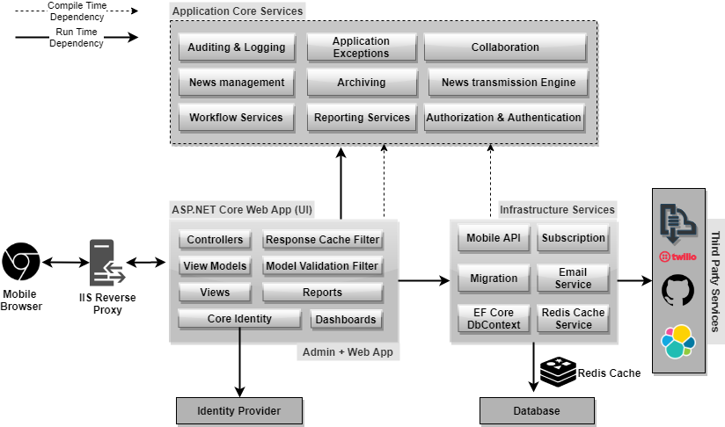

## TECHNICAL CONFIGURATIONS

### **DEVELOPMENT TOOLS**

* ASP.NET 4.5
* ANGULAR
* MS SQL
* HTML 5 / CSS 3
* Photoshop
* Web services, Ajax, JavaScript

### **BROWSER**

* Chrome version: 71
* Firefox version: 64
* Edge version: 17
* Safari Version: 12.0.1

### **HARDWARE**

The application is reliant on hardware interfaces to provide a seamless automated user experience.

Computer with Windows 8 or 10 OS

* Compatible Browsers as specified in section 3.5.2

### **Technical Standards**

* Testing Devices

Google Pixel     Android 7

Motorola Moto G Turbo Edition -   Android 6

-----------------

OS Version

Android: Android Lollipop and above

### **Technical Guidelines**

The guidelines provide instructions and conditions that will be adhered to during the development of the mobile application.

* API will be used, as the case may be, in realizing the features and functionalities mentioned
* The client will finalize the functional requirements and UI/UX before the commencement of the project
* Verbat will be testing the app in the mentioned devices only. Testing on devices other than the ones mentioned under the “Technical Standards “ will have to be specified and provided by the client at the beginning of the development phase
* The client will have to provide the details of the testing devices they are using before the start of development phase
* Client should provide the relevant Developer's Account credentials before the development phase. In case Verbat needs to create the developer id additional charges will be incurred by the client
* The duration mentioned in the project time line is for development and testing and any delay or time taken by the review team to respond will not be Verbat’s responsibility.
* The apps will be developed / created within the guidelines of Android play store and Ios app store.
* Verbat will strictly follow the guidelines provided by the respective stores.
* Verbat will inform the client if any of the client requirements /request deviates from it.
* Customization of the features of the app will be susceptible to the limitation imposed by the respective platform/ store.
* Once development commences the test device/screen sizes will not be susceptible to change. Any change requested by the client will have to go through change management
* OS version support will be limited to the ones mentioned in the technical specifications. Further support will have to go through change management

# OUT OF SCOPE

With the ever-evolving digital market, the requirement should be clear to both the parties involved, hence the importance of mentioning the out of scope details of the project. Following are considered to be out of scope while creating this proposal:

* Purchase of images, fonts and domain names
* Any language other than English and Arabic
* Content Writing/Proof reading/data replication/manual data entry
* Content or image procurement or uploading or editing
* Audit Trail
* Test Cases, Load Testing, Stress Testing, Performance Testing, Security Testing, End User Testing
* BI tools integration or reports generation engine,
* Adding new features to the application other than mentioned in the Functional Requirements. Such requests will be handled via change management. For Change management details, please refer section titled “Change Management” in the Proposal.
* Annual Maintenance Contract (Bug fixing, debugging, enhancements) – Please refer section titled “Maintenance and Support”, unless contracted for.
* Hosting Infrastructure and Maintenance (web and email hosting), unless contracted for
* Backup solution and Disaster recovery.
* Workflows engine.
* Multiple approvals workflows.
* Physical deployment onsite / installation of the application in devices and Physical connection, installation of system without the full support of the client’s infrastructure team.
* Integration with third-party, if any other than explicitly mentioned in the proposal
* Hardware Integrations / procurement and purchase
* Procurement of SMS gateway / payment gateway / email gateway
* SMS or payment gateway integration.
* Creation and management of social media pages.
* SSL Purchase and installation unless contracted for
* Relevant / related software libraries/licenses
* Application offline access or operations
* Active Directory integration

# PROJECT DELIVERY

### **PROJECT MANAGEMENT**

Verbat will dedicate a project manager for the proposed implementation. Verbat proposes the client to identify one project manager (CSPM – Client-Side Project Manager) who will be driving all activities undertaken by the client, and will be the single point of contact for Verbat.

The Verbat development center strictly follows industry standards on quality. Our project management process is governed by the Verbat Quality Management system and is verified internal audit programs.

### **ROLES & RESPONSIBILITIES**

Verbat will assign its own dedicated Project Manager (VPM – Verbat Project Manager) for the client. The VPM will be responsible for planning and management of all activities related to the project. The VPM will lead the co-ordination between Verbat and Client, thus enabling smooth transitioning of Client requirements to Verbat’s delivery team. Furthermore, the VPM will work closely with CSPM, on all periodic status updates and ensure high level visibility and comfort on the progress of the project.

### **SUPPORT AND SERVICES**

Based on the RFP shared by client, we plan to deploy a team to work full time on NMC on premise, which brings a blend of application designing experience with functional expertise to ensure complete coverage of business needs followed by a disciplined approach during Application development/enhancements.

### **STANDARD DELIVERY ACTIVITY SUMMARY**

|  |  |
| --- | --- |
| Activities | Description |
| Detailed Requirement Analysis | Verbat team to conduct detailed study of requirement for the application. If clarification is required, the team will reach out to Client for more information and/or time for discussions. |
| DB Design | DB design for central and test DB. |
| Software Requirement Specification document (SRS) | Once the requirement analysis is completed, Verbat team will submit the SRS document for approval |
| UI/UX , Prototype Design | Based on the SRS, Verbat UX/UI team will work on the UI/UX/prototype of the screens and submit for approval |
| Development | This involves detailed design and software development of Mobile Application. |
| Testing | Test Planning, test plan creations, internal, integration testing and user acceptance testing. |
| Deployment | Deploying the latest built in the agreed test server. |

Note: The above is the standard activity summary followed by Verbat. The deliverables may vary based on the project requirement.

### **DELIVERABLES**

* Project Plan
* Software Requirement Specification Document (SRS)
* UI/UX/Prototype Design
* Fully Developed & Tested Application
* Source Code

### **ESTIMATED DELIVERY TIME**

The project duration as mentioned in the RFP is 10 months.

*Note:*

* *The on-site team will work as per the UAE Working Days (Sunday to Thursday) and in UAE time zone. 8*5 working hour from customer premises @ Dubai. (Holidays will be taken into consideration while defining the project plan).*
* *Workstation/telephone/desk will be provided by the customer.*
* *Leaves/UAE holidays as per UAE policy.*
* *The resources will be deployed onsite post the confirmation of the project along with LPO, signed proposal and advance payment.*
* *Any ‘Change Request’ from client, post the initiation of development which will impact existing approved features/timeline will be considered as Phase 2.*
* *Documentation submitted after project initiation and system study supersedes any proposal or documentation submitted during initial requirement gathering / discussion / negotiation.*
* *Project plan will be submitted post the confirmation of project with necessary payments.*
* *All approvals and queries regarding the client requirement and any queries which may hinder the project advancement at any stage should be answered by the client without any delay, failing which the time delay will get added to the actual effort and timeline which was estimated.*
* *Any delay in getting the approvals of deliverables from client will cause change in timelines and the revised timelines will be updated in weekly status reports shared with client after the project commencement.*
* *On project confirmation, Verbat requires a lead time of minimum fourteen (14) days for resource mobilization.*

### **RISK CONTINGENCY PLANNING**

Verbat has identified various risk factors associated with this assignment and their impact on the project schedule. Here, we highlight our collective risks, analyze the impact of these risks on project execution and propose strategies to control and reduce impact.

| **Type of risk** | **IMPACT** | Risk Mitigation | Risk Handling |
| --- | --- | --- | --- |
| Scope Creep | **H** | Functions and features will be detailed in system requirement document and will go through client approval. Once this document is approved, all changes will go through the change management process for impact assessment. | Proper change management procedure will be implemented |
| Delay in customer feedback | **H** | The plan is prepared with sufficient lead-time for reviews and approvals.  The client is advised/ intimated on all dates connected to the document review and approval. | The request for feedback will be escalated if not attended to at the right time so that the schedules are not affected. Deemed acceptance criterion is finalized up-front and will be followed |
| Non-availability of necessary software, frameworks, database instances and infrastructure at client’s hosting environment (If hosting support is provided by Verbat) | **M** | Client will be informed in advance on these requirements. | Possible impact to schedule |
| Manpower attrition | **L** | All efforts will be made to ensure that all initiatives are process dependent. To mitigate risk Verbat/Client will train a person to ensure all back-ups are in place. | A new person will be appointed as early as possible, provided the required project-specific training and mentoring is in place - to minimise impact of attrition on the project |

*H-High, M-Medium, L-Low, NA-Not Applicable*

# CHANGE MANAGEMENT

Any addition which comes out of the project scope, upon and after the launch of the system will be considered as change management. Verbat recommends the following change management procedures for the same:

* Changes will be implemented only after raising a change request.
* Change requests will be studied and an impact analysis will be performed on the existing work flow.
* Upon assessment of the impact, effort estimation will be calculated and raised as an additional requirement.
* The change request will be initiated only after receiving a formal approval from the client for the additional changes raised.
* Changes which are out of scope will be charged at an agreed per man day rate (refer financial proposal) and approval from the clients will be availed before commencing on any change management.

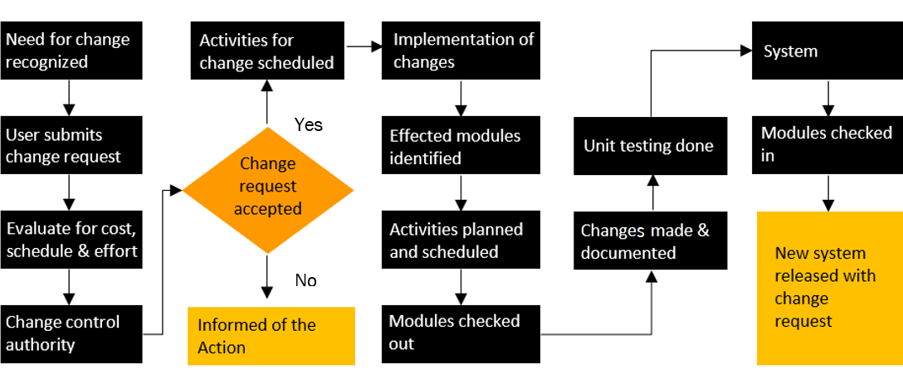

# MAINTENANCE & SUPPORT

* Maintenance and Support services offered by Verbat are as per the basic SLA terms.
* Additional Effort/change management request will be added towards Total Value of the Project to determine the AMC value for the next year.
* Maintenance support and warranty are limited to providing application support for ensuring the consistency of the look-and-feel, bug fixes and user issues i.e. maintenance and support of the existing features of the application.
* Support does not in any way cover providing technical or other support to the end users or hardware support. The maintenance agreement does not include functionality changes or feature additions which are handled as change requests which will be charged per man day rate. AMC does not include server support, maintenance and application deployment.
* AMC charges will cover Support and Debugging.
* Gap in AMC - In case if the client does not opt an AMC for a year and wants to renew it after that period, 50% of the AMC amount for the year for which AMC is not taken will also be payable if the client wishes to renew the AMC contract.

|  |  |  |  |  |
| --- | --- | --- | --- | --- |
| SLA Type | Max Response Time | | Max Resolution Time | Target |
| Basic | 1 working day | 3 working days | | Request / incident / problem tickets |

Note:

* *Time zone applicable as per UAE Time Zones (8.00 AM to 5.00 PM, Sunday to Thursday)*
* *Please note that the AMC support shall start only after all the necessary sign-offs (AMC Document) to this effect have been given.*
* *It is not mandatory that the client should opt for an AMC. The client will still be supported on an ad-hoc basis on an agreed man-day rate.*

*AMC Option: Client can opt for time and material based Annual Maintenance, the details of which will be shared post the completion of project.*

# TERMS AND CONDITIONS

## STANDARD ACCEPTANCE CRITERIA

* UAT (User Acceptance Test) sign off should take place within 14 Days from the first release of the application and the acceptance confirmation needs to be mailed to Verbat failing which Verbat will consider the project as approved by the client.
* Any comments and reasons for rejection need to be documented and the same needs to be sent as an email from the official mail id of client to Verbat on or before 14 days from the first release.
* Timeframe for acceptance for any further release will be mutually agreed and finalized between client and Verbat depending on the UAT Comments.

## WARRANTY

* Verbat shall provide a bug ﬁx warranty at no additional cost for 30 days from the date of acceptance of the project, for correction of any errors in the developed application that may be attributed to Verbat.
* However, this does not cover modifications by Client, or use of the application on an environment other than the proposed environment, or other circumstances outside Verbat’s reasonable control. In such a case Verbat reserves the right to charge for its services.

## SOURCE CODE & INTELLECTUAL PROPERTY RIGHTS

* Upon completion of the Project and 100% completion of the payment, the client will have access to the source code except for proprietary codes, developer tools and third-party applications.
* The solution offered will be the intellectual property of the client and will be made available to the client on an “unlimited license” basis.
* No person or organization, other than Verbat or any person authorized by Verbat in writing, has any permission to modify/change the software solution to be eligible to get continued support from Verbat as per the support terms defined under this document.
* Verbat accepts no liability or damages of any kind arising out of use or non-use of the software delivered. The responsibility of testing of software lies with the client.

## GENERAL TERMS AND CONDITIONS

* Offer Valid for 90 calendar days from the date of submission of the Proposal.
* An average of 20 working days is assumed in a month.
* All the documentations will be provided in English.
* Third party components may be used to develop this application.
* The scope of the project is to develop the application as detailed in the scope of the project and mentioned in this proposal. Any changes or additions will have to go through our change management process.
* This proposal is derived and concluded from either the RFQ /RFP/data shared via email / information transferred during an initial requirement analysis meeting / tele-conversation. Verbat reserves the right to change the terms of this proposal if the final terms (including the costing), features & functionalities and timelines are changed during the course of the project. Hence any fees quoted / timeline committed in this proposal may not be considered as final unless agreed upon and signed by both parties.
* All source codes and other project artifacts will adhere to the Verbat document templates and internal coding standards.
* The documents delivered to the client include the ones mentioned under ‘Deliverables’ and these will adhere to Verbat’s internal document standards.
* Acceptance criteria shall be based on the clauses which were mutually discussed between Verbat and client at the Requirement Analysis phase. The same will be documented and approved by both parties through official emails.
* In the event that the Client requires any extension of the proposed acceptance schedule, the associated effort and cost of such extension will be mutually reviewed.
* If the project needs to be put on Hold / Stop, a minimum notice period of 1 week is required along with the duration of the holding period. Thereafter Verbat will make a final decision based on the request.
* If deployment is done in the client’s server, Verbat will not be held responsible for any performance issues arising due to hardware malfunctions.
* The Client is responsible for all data-backups in case the application is not hosted on the Verbat server.
* All source codes will only be delivered or uploaded on the production server after the due payments are made to Verbat.

## GENERAL ADMINISTRATIVE, TECHNICAL & FUNCTIONAL ASSUMPTIONS

* Detailed system study is required before the start of the project.
* During the requirement gathering phase, authorized personnel from the Client’s side are expected to be available for discussions and finalization of the HLD (High Level Design), before development commences.
* Type of reports, formats if under the scope of the project, need to be specified by the Client before the project sign off.
* Verbat assumes that all sign-offs from the Client will be provided within the agreed and specified timeframe.
* The client should provide the relevant information and data, well in advance of the execution of the related activity. Non- availability of this information or data may lead to an interruption of work, which may result in a delay in delivery as well as additional costs to the client.
* The Client should possess a server with the technical specifications recommended by Verbat for the proposed application.
* The Client will be provided with a one-time training (train the trainer) on how to use the application via a video conference (maximum of 4 hours). Additional training requests will be charged at cost to the client.

# COMPANY REFERENCES

**Client Name – Ministry of Education (MOE)**

Project Name: Open Educational Resource Platform (OERP)

Location: Dubai, U.A.E

Ministry of Education has requested Verbat to develop a UAE- Open educational resource platform (OERP). The aim of this platform is to provide a centralized online platform where UAE and others can view, share and contribute their contents. Furthermore, this portal will allow UAE-MOE to track and monitor the progress through a dashboard. All information related to OER such as issue date, source, current state, future state, release dates along with best practices shall be captured.

**Client Name – Department of Seaports and Customs (Government of Sharjah)**

Project Name: Customs Clearance Portal

Contract Type: Time & Material

Resource Deployment Model: Offsite

Department of Seaports & Customs, Sharjah, Sharjah Seaports Authority manages the three ports of Sharjah Port Khalid, Port Khorfakkan and Port Hamriyah. The three ports of Sharjah are the leading trade gateway to the UAE and handle all kinds of ships and caroges. The three ports in total have 33 berths, handle in excess of 10 million tons of bulk and general cargo, over 2.5 million TEU's of containerised cargo, around 52000 ro-ro units and over 6500 vessels in a year. Cargo volumes handled have been recording consistently steady growth over the last several years.

Sharjah Ports resource deployment model comprises of Offsite resource (Verbat Resource) and Onsite Project Manager (from client’s side).

**Client Name – Sharjah Commerce and Tourism Development Authority (Government of Sharjah)**

Project Name: Permit Issuance and Inspection System

Contract Type: Fixed Bid

Location: Sharjah, U.A.E

Established in 1996, the Sharjah Commerce and Tourism Development Authority (SCTDA) is tasked with promoting commercial and tourism activities in the emirate of Sharjah. Sharjah intends to provide a sustainable tourism product with a unique and distinct tourism experience in the desert areas of the emirate. This is geared towards attracting the interest of various tourism companies, specifically tour operators, to focus on Sharjah when organizing desert trips and desert adventures activities within these areas. Consequently, this would be beneficial to the tourism sector and will contribute further to Sharjah’s economy. Hence, the Sharjah government has decided to organize desert tourism activities through this project; the issuance of permits to all tour vehicles entering the desert areas of Sharjah for desert safari activities owned or operated by tour operators along with the day to day inspection tasks carried by inspectors who can issue fines and attach evidences for further actions.

Sharjah Tourism resource deployment model comprises of Offsite resource (Verbat Resource) and Onsite Project Manager (from client’s side)

**Client Name – Rulers Representative Court (RRC)**

Project Name: Smart System

Contract Type : Fixed Bid

Location: Abu Dhabi, U.A.E

Verbat was assigned to develop a new Document Management and Archiving System called Smart System. The SMART System offers an effective solution for RRC enterprises to manage activities like citizen’s affairs, protocol, support services etc. It enables internal users to log requests, approve and follow up until it completes the RRC document process cycle for the various day to day business operations. The Smart system app allows the client to submit documents using pre-designed templates and follow up on the status of petitions.

**Client Name – MBC**

Project Name: Security Inspection System

Contract Type: Fixed Bid

Location: Dubai, U.A.E

Smart Security System facilitates a sophisticated and structured approach to execute the daily security checklist to be used by the security patrol users. In addition to the ability of recording concern/issues as well to be viewed at any time as reports.  The application includes different users like Super Admin, Branch Admin, Inspector, Resolver and Viewer. The Inspector user reports patrol issues and concern issues using android mobile application. Branch admin assign the patrol issues to the resolver. Viewer will be able to see the issues and concerns related to the particular branch.

**Client Name – Carrefour Hybris Project**

Project Name: Software Quality Assurance Managed Services

Contract Type: Time & Material

Resource Deployment Model: Hybrid (Onsite + Offsite)

Founded in 1992, Majid Al Futtaim is the leading shopping mall, retail and leisure pioneer across the Middle East and North Africa (MENA).

A remarkable business success story, Majid Al Futtaim started from one man’s vision to transform the face of shopping, entertainment and leisure to ‘create great moments for everyone, every day’. It has since grown into one of the United Arab Emirates’ most respected and successful businesses spanning 13 international markets, employing over 27,000 people, and achieving the highest credit rating (BBB) among privately-held corporates in the Middle East.

Carrefour testing team comprised of 20 resources inclusive of Onsite Project Manager, Onsite Test lead and Offsite Test Engineers

**Client Name – Ministry of Foreign Affairs**

Project Name: VISA Scheduling System

Contract Type: Fixed Bid

Location: Dubai, U.A.E

A web based application for the visa applicants and respected sponsors to schedule appointment for the security verifications. The system allows online payment facility. The application features include option for the sponsor to schedule appointments, option for the super admin to manage country and sites, manage other admin users and set e-mail/SMS notifications.

# ABOUT US



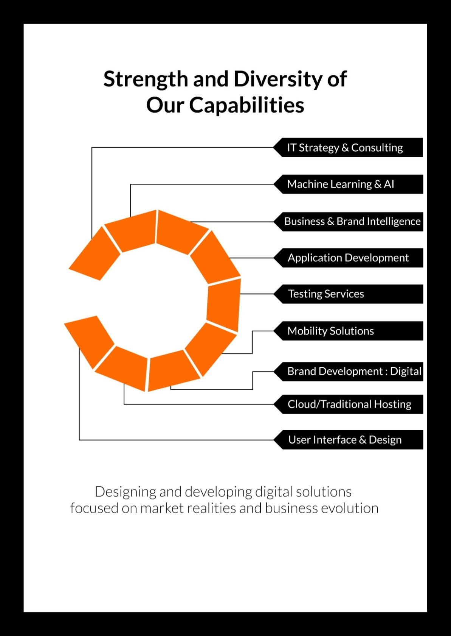

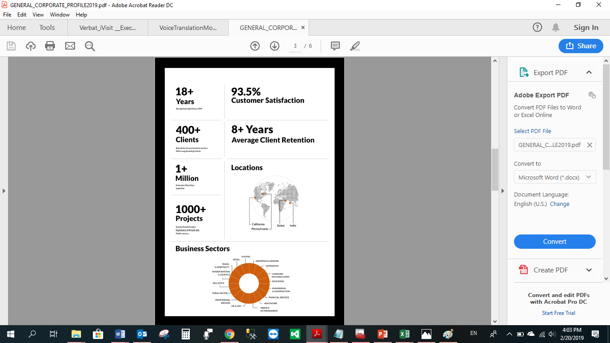

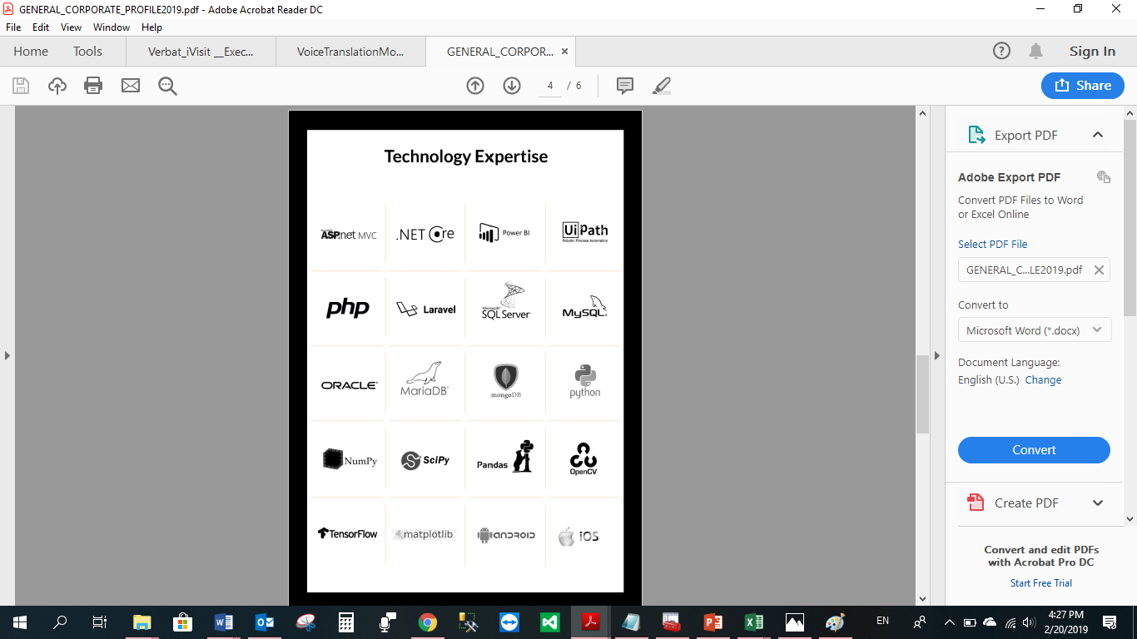

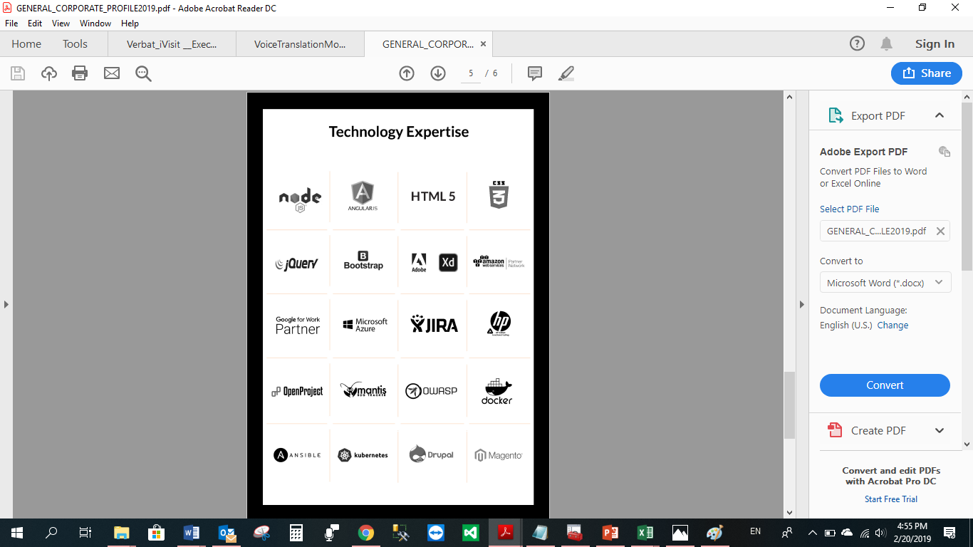

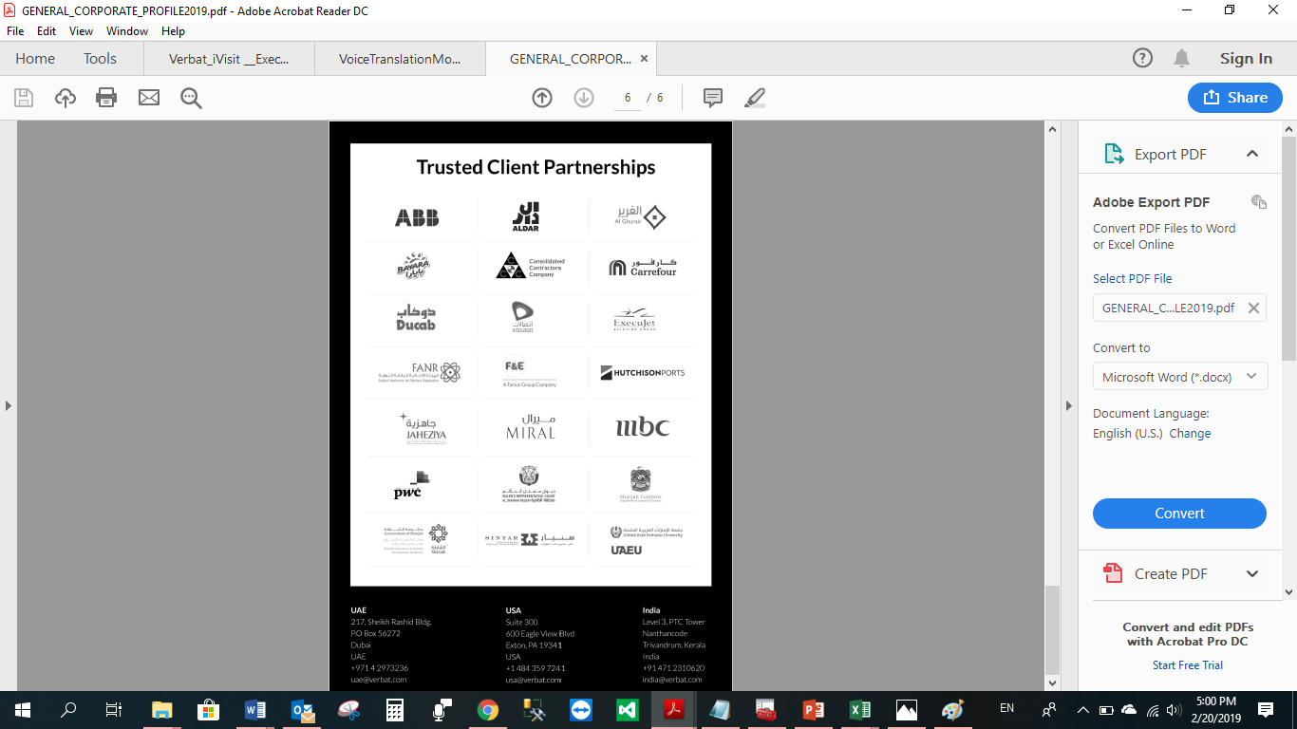

**WITH OUR**

**SINCERE THANKS.**

CONFIDENTIALITY NOTICE:

This Proposal is conﬁdential and contains proprietary information and intellectual property of Verbanet Technologies LLC. Neither this proposal nor any of the information contained herein may be reproduced or disclosed under any circumstances without the express written permission of Verbanet Technologies L.L.C (hereby known under its brand name of Verbat in the United Arab Emirates). 2019. All Rights Reserved.